Acquisition of leaf Point Cloud Data VIA STEREO IMAGES and

computer vision methods

Senior Thesis in Computer Engineering

University of Illinois at Urbana-Champaign

Advisors: Professor Narendra Ahuja & John M. Hart

August 2023

By

Daniel Gros

**Abstract**

With the evolving nature of climate change and the consequential plant growth issues around the world it is becoming increasingly important to be able to create the next generation of plants that will be able to withstand the changing environment. At UIUC researchers are involved in an interdisciplinary project experimenting with genetic modifications on plants and tracking their growth to measure the effectiveness of these modifications on the plant’s ability to survive in drier and hotter climates[?]. Metrics that communicate the quality of growth can be gathered from a leaf’s phenotype data, including its area. This project aims to allow researchers to track plant growth by retrieving leaf area solely via the acquisition and processing of bird’s-eye view stereo images.

Completion of the research project and application to practical software involved two broad fields of work. The first was training a machine learning model to be able identify individual leaves; accomplished using the open source Matterport implementation of Mask R-CNN. And the second was the ability to compute the width of the leaf after identification; using the stereo images and a leaf mask to acquire a point cloud of the segment, the width is measured by computing the Euclidian distance of the points on the widest part of the leaf.

This research project and the resulting software produced by it demonstrate an effective workflow for accomplishing leaf measurements with computer vision. These products are a step in allowing leaf size measurements to be produced with ease, helping researchers track plant growth and improve their experiments. This research will provide a tool to use in helping the transition to a world with an ever changing and worsening climate.

Code will be made available.

Keywords: Mask R-CNN, Instance Segmentation, Sorghum, Geodesic, Point Cloud, Plant Phenotype

For an extensive survey of the filed we refer the reader to [16, 18]

“out of the scope of this paper” for things I don’t need to cover

**Acknowledgments**

I want to thank the following people for the help with my Senior Thesisi:

Professor Ahuja for agreeing to be my thesis advisor and sticking with me despite the issues along the way including topic change and completion delay.

John M. Hart for being my mentor throughout the thesis project, helping guide the project and my work, and being a source of encouragement.

Jeremy Ruhter for being my contact in the greenhouse, for working with me to setup the ZED camera, and for being patient with all the issues during setup.

Tracy Johnson for providing space and plants for us to photograph and for being very informative relating to Sorghum characteristics.

Yunxuan Yang for helping with the annotation of images and Aaron Gros for helping with the visualization of point clouds.

Contents

1. Introduction 1

1.1 Background 2

1.2 Research Goals 2

1.3 Significance 3

1.4 Limitations 3

1.5 Structure 4

2. Literature Review 5

2.1 Instance Segmentation on Leaves 5

2.1.1 3D Point-Based Model for Instance Segmentation on Leaves 5

2.1.2 2D Image-Based Model for Instance Segmentation on Leaves 6

2.1.3 Selected Instance Segmentation Approach 8

2.2 Leaf Width Measurements on Point Clouds and Meshes 8

3. Methodology 10

3.2 Stereo Image Acquisition and Processing 11

3.2.1 Greenhouse Setup 11

3.2.1 ZED Camera and Data Collection Setup 13

3.2.2 Image Processing with ZED SDK 16

3.2.3 Software Calibration and Control Photos 17

3.3 Training Mask R-CNN Model 19

3.3.1 Image Annotation 20

3.3.2 Image Processing Pre-Training 21

3.3.3 Model Training 23

3.4 Measuring Leaf Width with Point Cloud 25

3.4.1 Point Cloud Acquisition 25

3.4.2 Cropping Point Cloud 25

3.4.3 Distance Measurements using Point Cloud 25

4. Research Results 26

4.1 Instance Segmentation Model Accuracy 26

4.2 Width Measurement Accuracy 26

4.2.1 Control Photos and Measurements 26

4.2.2 Research Project Measurements 27

4.2.3 Difference in Measurements 27

5. Discussion 28

5.1 Instance Segmentation Model Analysis 28

5.1.1 Key Findings 28

5.1.2 Limitations 28

5.1.3 Future Work 28

5.2 Width Measurement Accuracy 28

5.2.1 Key Findings 28

5.2.2 Limitations 28

5.2.3 Future Work 28

6. Conclusion 30

6.1 Research Answers 30

6.2 Contribution 31

6.3 Further Research Opportunities 32

Appendix A: ZED Camera Image Capture and Processing 33

A.1 Overview 33

A.2 Code 33

Appendix B: Instance Segmentation Model 35

B.1 Overview 35

B.2 Code 35

Appendix C: Leaf Width Measurement Code 36

C.1 Cropping with Mask 36

C.2 Distance Measurement 36

References 37

# 1. Introduction

Crop production is key for our society to provide feed, food, and other resources. During the growth of a plant, the development of its functional body is affected by a dynamic process between its genotype, the performed management, and the environment [4]. Thus, plant scientists and breeders continuously assess phenotypic traits as an expression of the genotype for individual plants to generate new genetic variations of crops that show desired traits. Outside greenhouses, this in-field assessment is conventionally done manually, which is time-consuming [20]. In contrast to traditional phenotyping performed manually, vision-based systems have the potential for an objective and automated assessment with high spatial and temporal resolution, providing a method of performing the same assessment at a larger scale, in less time, and more objectively. One of such systems’ objectives is to detect and segment individual leaves of each plant since this information correlates to the growth stage and provides phenotypic traits.[1]

Summary of things below

## Background

The increasing severity of climate change is significantly impacting plant growth. Changing temperature, precipitation quantity and timing, atmospheric carbon dioxide levels, soil moisture, and nutrient availability can affect photosynthesis, respiration, and water use affecting plant growth [2]. As a result plant growth worldwide is at an exponential decline affecting the ability of plants to produce the expected yields. Consequently, research is being conducted in many institutions including the efforts of Professor Leakey at the University of Illinois at Urbana-Champaign to genetically modify plants to be able to withstand these changing environments. These experiments require large amounts of phenotype data to be consistently observed and measured by a team of field data collectors. The manual methods of collecting the phenotype data can slow the research down, limit the scale of the research, and even affect the research negatively via imprecise data recordings and larger measurement errors. As a result, current phenotyping methods are a bottleneck in plant gene research [3].

For the visual components of the recorded phenotype data, computer vision methods are being utilized to facilitate the data collection process. For example, one of the important metrics that communicates effective growth in plants is leaf size. Measuring leaf area is difficult under field conditions and common practice is to remove, scan, and measure leaves individually [4]. This is a slow and tedious process prone to error. Approaches have been developed that utilize computer vision methods to automate and increase the reliability of the measurements. However, these computer-vision-based approaches remain in their infancy and can be inaccurate when it comes to leaves outside of the laboratory, which are in dense clusters, overlap, and acan curve and curl. This research project aims at making extraction of phenotype data easier, as in the case of leaf area, by providing researchers with an accurate and precise mode of individual leaves.

This research project aims to accomplish this in an accessible and noninvasive manner: without the need for specialized equipment and without the need for a significant number of people to take the measurements by hand. This can be accomplished with the use of stereo camera images. After performing initial image processing, 2D stereo images can be used to perceive depth the same way our eyes perceive depth. With this perception of depth one can generate depth maps, point clouds, and meshes. As a result, solely with a pair of offset 2D images, it is possible to digitize the 3D structure of a cluster of leaves. The challenging part is isolating individual leaves that can be measured.

## Research Goals

The aim for this research project is to enable researchers who are conducting experiments on plants that require the collection of phenotyping data to perform the acquisition of data more easily and quickly.

The research goals are to define a method and develop a program that researchers can use to acquire leaf models for plants in environments with dense leaf clusters.

Questions this research will address are:

What is an effective process at isolating and modeling a leaf from stereo images?

What is the implementation for isolating and modeling a leaf from stereo images?

## Significance

With the growing effects of climate change, crop yields are declining and researchers are hard at work developing new breeds of plants to thrive in the new environments. This project intends to provide these researchers with the tools to conduct this research more effectively and efficiently.

Although, this project serves as a first step in the automation of leaf phenotype data collection, the defined process and developed program can be altered for other applications that require modeling of objects. This could include other types of research: automating food harvesting, facilitating detection of large tumors, etc. This project can serve as a first step in development in the space of object modeling with stereo images.

## Limitations

Although the goal of the project is to define and develop a program that can be used by plant genetic researchers to collect phenotyping data on plants certain factors in the development of the project limit the use case of the end product.

The entirety of the project was done in partnership with a research team that works on sorghum. As a result, the machine learning model used to identify individual leaves was trained on sorghum leaf data and is intended to only be accurate at identifying leaves for sorghum plants. In addition, all data used for the training consisted of healthy and well-lit leaves. Applying the model to environments outside of well-lit and healthy sorghum would require a larger dataset and further training of the model.

## Structure

Chapter one has outlined the purpose of the research project and what it entailed. It focuses on describing at a high level the problem the project intends to address, the method to addressthe problem, the potential applications of the project, and some limitations of the project.

Chapter two outlines the survey conducted to determine the most effective design choices. It describes the different methods for performing instance segmentation on leaves and the different methods for measuring object width on 3D models of objects.

Chapter three describes the methodology used to accomplish these goals. This chapter steps through the setup involved for data acquisition, the process in creating, training, and using the instance segmentation model, and the code written with the aim of extracting the 3D structure of an individual leaf for future measurement of leaf aspects.

Chapter four communicates the level of effectiveness of the research project in obtaining a precise and accurate result. It defines the results that pertain to the output of the Mask R-CNN model and the output of the leaf model acquisition process.

Chapter five analyzes the results outlined in chapter four. It describes the findings of the project and the work that can be done to continue the project and answer further research questions.

Chapter six outlines the answers to the research questions and how the research project contributed to the technical space. This final chapter also describes the opportunities for further research utilizing the research from this project and extending its functionality and application.

# 2. Literature Review

The process of acquiring the leaf model consists of two sub processes in this project. First, acquiring a 2D instance segmentation of a leaf from raw images of a scene. Second, applying that 2D segmentation to a 3D point cloud acquired from stereo images of the same scene. A third process was also reviewed in this section for the future use of this thesis work toward automatic phenotype data collection of leaves. In preparation for usage of this project in the estimation of leaf area, via width measurement and the associated width-area relationship of sorghum leaves, the literature review included research on the subject of different methods calculating leaf width from a leaf model.

The process of acquiring the leaf width consists of two sub processes. First, acquiring a 3D representation of a leaf from raw images of a scene. Second, measuring the width of a 3D representation of a leaf. In preparation for the design of these subprocesses, two areas were surveyed: instance segmentation methods on leaves and leaf width measurements on point clouds and meshes.

## 2.1 Instance Segmentation on Leaves

A survey into the current instance segmentation methods for leaves resulted in two common approaches: 3D training and inference on point cloud [3], [5], [6] and the traditional training and inference on 2D images [4], [7], [8].

### 2.1.1 3D Point-Based Model for Instance Segmentation on Leaves

Current point cloud instance segmentation approaches on leaves involve extending a deep neural network that consumes point cloud data. One of the foundational approaches is called PointNet developed by C Qi, H Su et al. This network provides a unified approach able to perform object classification, part segmentation, and semantic segmentation with point clouds. The architecture is visualized in Figure 1. The classification network takes n points as input, applies input and feature transformations, aggregates point features by max pooling, which results in output scores that are classification scores for k classes. The segmentation network extends the classification network, concatenates global and local features, and outputs per point scores [9].

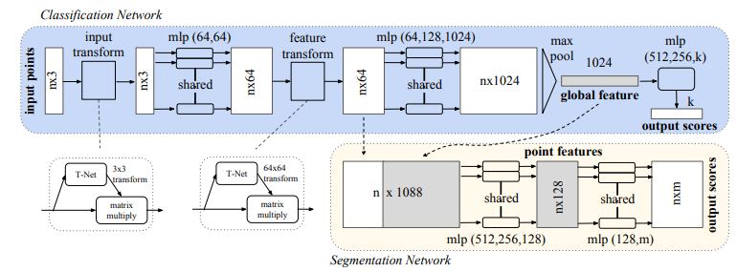

Figure . PointNet Architecture [9]

This architecture is applied to plant and leaf instance segmentation in the three following papers. Y. Li et al developed a process of segmenting point clouds with a focus on high-throughput data acquisition before deep learning. The data acquisition was performed using the MVS-Pheno platform to acquire high-throughput data and an internally built labeling tool, Label3DMaize, was used for the labeling. For the deep learning segmentation, Y. Li et al used PointNet to implement stem-leaf and organ instance segmentation achieving mean precision scores over 0.91 and f1-scores over 0.85 [3]. D. Li et al similarly used PlantNet and improved upon it with a 3D Edge Preserving Sampling strategy for preprocessing input points, a Local Feature Extraction Operation module based on dynamic graph convolutions, and a semantic-instance Feature Fusion Module. The results outperformed other instance segmentation deep learning networks by over 13.3 percent [5]. K. Turgut et al compared the latest available point cloud segmentation approaches on instance segmentation with rosebush including PointNet and its improved version PointNet++. They utilized a labeled rosebush dataset and a synthetic model. The addition of the model improved the results of the model [6].

The papers demonstrate the effectiveness of point cloud instance segmentation. However, this effectiveness comes with its conditions. Y. Li et al outline that the great performance of the model on the is mainly due to a dataset of high quality and diversity [3]. This condition is particularly relevant as Y. Li et al and D. Li et al express how there is a shortage of well-labeled point cloud datasets in the plant domain [3], [5]. Consequently, pursuit of a point-based convolutional neural network model involves the acquisition of a high quality and diverse dataset. Acquisition of high quality point cloud data is not an accessible process and requires specific environmental conditions and tools: no wind disturbances, indoors, even and consistent lighting [3]. Not only is the acquisition of this data much more difficult, the annotation of this data and procedures for constructing 3D models for training are both much more time demanding and error-prone than the image-based model counterpart [6].

### 2.1.2 2D Image-Based Model for Instance Segmentation on Leaves

Most current 2D image instance segmentation approaches on leaves involve extending and training the Mask R-CNN model for the purpose of segmenting leaves. K. He et al’s Mask R-CNN is self-described as “simple to train and […] easy to generalize to other tasks” and is the reason it’s widely used for all types of applications including instance segmentation with leaves. Another improvement of Mask R-CNN compared to its older counterparts is its ability to accurately perform instance segmentation even among overlapping objects.

Mask R-CNN is an extension of Faster R-CNN which is an extension of Fast R-CNN. Fast R-CNN takes as input an image and object proposals. The network processes these with convolutional and max pooling layers that produce a feature map. The feature map is used to calculate softmax probability estimates and four numbers that encode refined bounding-box positions for each of the K object classes [10]. Faster R-CNN attaches a “Region Proposal Network”(RPN) before the Fast R-CNN architecture which reduces the number of object proposals and quickens the model [11]. Mask R-CNN leaves the RPN intact but adds a parallel process along with the Fast R-CNN architecture. The parallel process outputs a binary mask prediction for each region of interest along Fast R-CNN [12].

Use instead???:

Mask R-CNN includes three functional branches of classification, bounding-box (bbox) regression and mask branches, and the instance segmentation process is as follows. Firstly, input one image into a base conv-net to obtain the feature maps. Secondly, a Region Proposal Network (RPN) recommends a set of Regions of Interest (ROIs) that may include instances base on the feature maps. Thirdly, realign each ROI feature through a ROIAlign layer. Finally, predict the object category, box location and binary mask (indicates each pixel as target or background) for each ROI in parallel.[7]

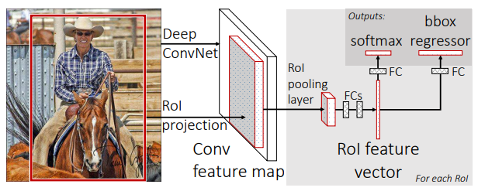

Figure . Fast R-CNN Architecture [10]

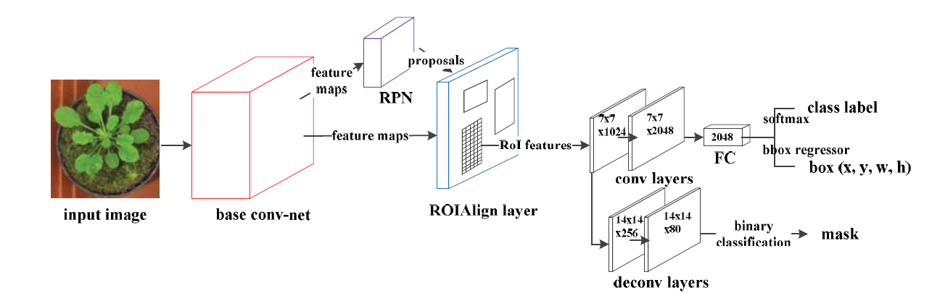

Figure . Mask R-CNN Architecture [7]

This architecture is applied to plant and leaf instance segmentation in the three following papers. L. Xu et al tested different extensions of Mask R-CNN and trained the models to segment and count the number of leaves. The resulting model was able to accurately count leaves, even when overlapping, when feeding the model top view photos of individual round-leafed plants [7]. J. Schrader et al developed an android application that obtains the leaf size via instance segmentation with Mask R-CNN after placing picked leaves on a solid background [4]. J Champ et al extended Mask R-CNN for the fine detection and segmentation of weeds and crops [8].

The papers and application of Mask R-CNN to a plethora of segmentation applications demonstrate its effectiveness for a variety of objects in difficult environments. L Xu et al outlines that the reason for Mask R-CNN’s effectiveness in leaf segmentation can be attributed to the RPN network that takes multi-scale anchors for the region of interest propositions, making leaves with different sizes, ocluded leaves, and leaves of different shapes recognizable [7]. Although Mask R-CNN is more accurate under these conditions compared to other models, it can still produce erroneous results with small leaves and heavy occlusion. That said, the model’s great effectiveness at segmenting different kinds of leaves with small amounts of data makes it an attractive model to use with leaf segmentation.

### 2.1.3 Selected Instance Segmentation Approach

Despite the greater precision of 3D point-based models that utilize the extra dimension for segmentation, the approach is not feasible for this project as it requires the acquisition of high quality and diverse data with intrusive technologies like LiDAR scanners in heavily controlled environments. The constraints of this project include data acquisition solely obtained through stereo images in environments with dense foliage that cannot be affected. This makes it impossible to develop accurate and reliable 3D point-based models for this project. In addition, one of the project’s aims is for the continual application to other research teams with varied environments and plant types, for example using images from row farming as training data. The difficulty in acquisition and annotation of 3D point-based datasets makes that path unappealing. This project will perform the instance segmentation tasks via the 2D image-based model Mask R-CNN. This approach will allow the research team the flexibility to collect data in changing environments, dense foliage, without tampering with the plants, and without the need of excessive time in annotation.

## 2.2 Leaf Width Measurements on Point Clouds and Meshes

The problem of calculating the leaf width with the use of point clouds and meshes can be reduced to that of calculating the distance of the shortest path between the two edge points along the body of the leaf. As the description points out, this problem is a graph theory problem of finding the shortest distance of two nodes on a graph. Most of the algorithms that calculate distance of shortest path fall under single-source shortest-path (SSSP) and all-pairs shortest-path (APSP) [GRAPHWALKS!!!]. APSP aims to solve for the shortest path between every pair of source and destination nodes, this is unnecessary for the leaf width problem. SSSP aims to solve the shortest path between one source node and all other nodes in the graph. SSSP ………..solved by BFS and Dijkstra’s algorithm in O(

A survey into the current object measurement methods on point clouds and meshes for leaves resulted in two common approaches for calculating the geodesic distance between two vertices: calculating the distance as a sum of the shortest path segments in a mesh (using traditional shortest path algorithms as previously reviewed) and using algorithms from differentiable geometry under the assumption of a discretized differentiable surface [GRAPHWALKS!!!].

__

A survey into the current object measurement methods on point clouds and meshes for leaves resulted in two common approaches for calculating the geodesic distance between two vertices: single source geodesic distance aka “global” methods (one source to all other points) and point-to-point geodesic distance aka “local” methods (one source to one destination). For this project “local” methods are most effective. Local methods include polygon-based methods and graph-based or point-based methods. Polygon-based methods use the triangle-mesh topology as the domain for computer geodesic distance. Graph-based methods use a graph constructed from a triangle mesh or point cloud of the ground truth surface [Optimal point-to-point]. H Yu et al uses a point-based method on a point cloud using nearest neighbor to make a rough estimate of the shortest path between two points. Then the estimation is iteratively improved by using a linear system to reduce the geodesic curvature [geodesics on point clouds, optimal point-to-point].

__

R A Potamias et al implemented a neural-network-based approach at estimating the geodesic shortest path. ‘GraphWalks’ estimates the geodesic shortest path by navigating from the source node to one node to the next based on its probability of being the optimal way of reaching the destination node in the shortest distance. Their approach can most effectively be applied to meshes and consists of three stages: vertex embedding layer that assigns topology aware features to nodes, the path descriptor avoids paths not aligned with the current predicted path, and the point selector which selects the next node in the path. This approach outperformed the Euclidian distance approach and cosine similarity approach to calculating the shortest geodesic distance of two points [GRAPH WALKS!!!].

A Agathos et al implement an approach suited for noisier point clouds. As opposed to using an error filled mesh converted from the noisy point cloud, their approach calculates the geodesic path on the noisy point cloud. [Optimal Point-to-Point geodesic].

Mention looking into flattening and then Euclidian distance, but flattening was much harder than geodesic path

** didn’t have time to apply the proper approach to my project -> calculating geodesic distance. Instead calculated Euclidian distance. This section will outline the approach that should be done next, part of “next steps/research opportunities” section

3D Geodesic Distance on Meshes and Point Clouds

Done:

* Relevant papers acquired and skimmed.

To Do:

* Read more thoroughly and write section.

# 3. Methodology

The project is split into five parts: data collection, point cloud and image generation, acquisition of leaf mask, scaling of leaf mask, and point cloud cropping.

The data collection phase involves determining what data to collect, where to collect the data, and how to collect the data. As the project was performed in partnership with a lab working on sorghum genetic modifications for drought resistant plants, the collected data are images of sorghum plants at different stages of growth. The data was collected in one of the UIUC greenhouse rooms in which they are performing their experiments. And the data was collected via a stereo camera called the “ZED” camera by Stereo Labs. The data is collected in a proprietary .svo format that needs to be processed by the ZED SDK to obtain more specific and useful data.

The generation of the point cloud of the scene is obtained by first extracting the coordinates and color values of all the points from .svo recordings using the ZED SDK and provided API, and then formatting the data into a data structure that is easy to read and manipulate. The 2D image generation is performed using the provided ZED SDK API.

The acquisition of a leaf mask is obtained by training an instance segmentation model to segment a leaf with annotated images of sorghum leaves at different stages of its lifecycle, in three different rooms, with three different distances between the camera and the plants.

The scaling of the leaf mask is performed via experimentally defining cutoff planes in the point cloud and a ratio between the dimensions of the mask and the point cloud. The method of scaling the leaf mask in this project is imprecise and error prone and a point of improvement for future work.

The point cloud cropping is performed by using the leaf mask as a filter in the length-width coordinate system of the point cloud.

Figure 4 describes the flow of the research project’s product.

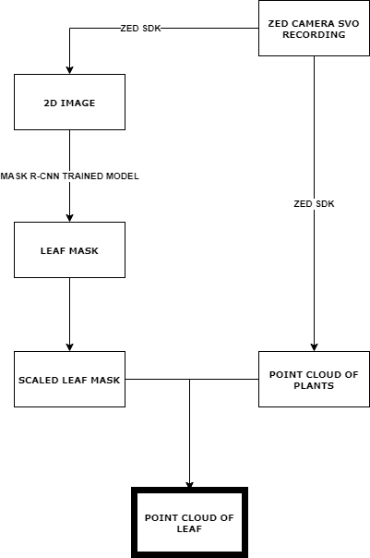

Figure . Project Workflow

## 3.1 Data Collection

Need at least short intro into next sections

### 3.1.1 Greenhouse Setup

The research project was performed with a focus on its application to the Sorghum plant. The first stage of data collection was performed in a predefined environment by the genetic researchers this project was done in partnership with. This environment was a room in the University of Illinois Plant Biology Greenhouse filled with different genetic varieties of Sorghum. Figure 5 showcases the room at the start of the data collection process.

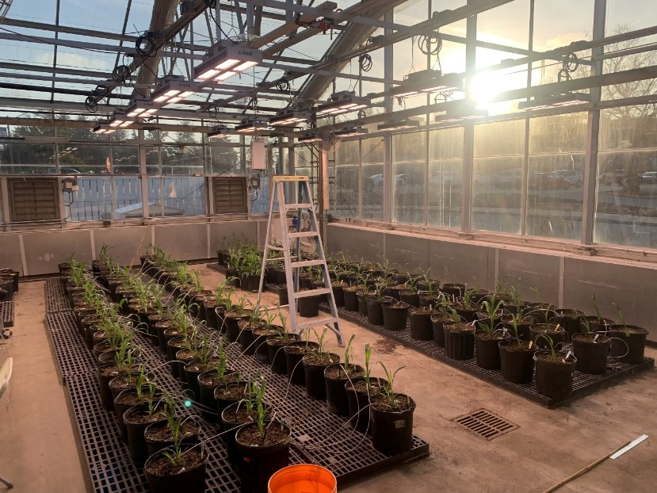

Figure . First Greenhouse Room at Week 0 of Collection

After 9 weeks the Sorghum plants in the first greenhouse room matured to a point where there were no more significant changes in leaf size. Figure 6 showcases the room at this point.

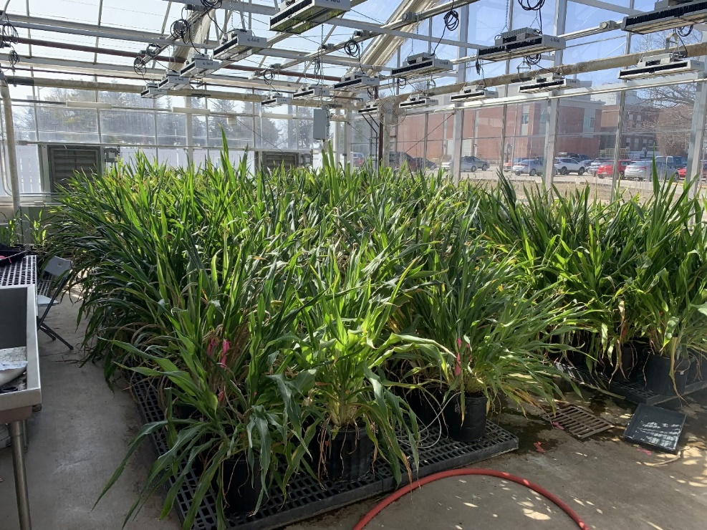

Figure . First Greenhouse Room at Week 9 of Collection

As a result of the unchanging leaf size, the setup was moved to a second greenhouse room to obtain more useful data. In the second room Sorghum plants with no genetic modifications at different points in the growth cycle were grown and photographed. The second room focused on young sorghum plants as technical issues caused loss of data in the early days of data collection in the first room. Figure 7 showcases the setup in the second room.

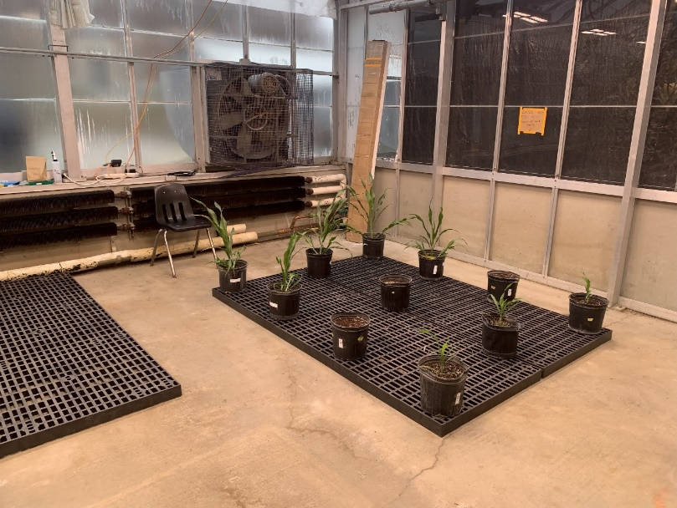

Figure . Second Greenhouse Room at Week 0 of Collection

### 3.1.2 ZED Camera and Data Collection Setup

Once the subjects of the data collection were defined and ready to be photographed, the next step was setting up the data collection tool. The ZED camera and ZED box, a processing unit used for the camera, were fastened onto a wooden plank, and placed near the ceiling as seen in Figure 8.

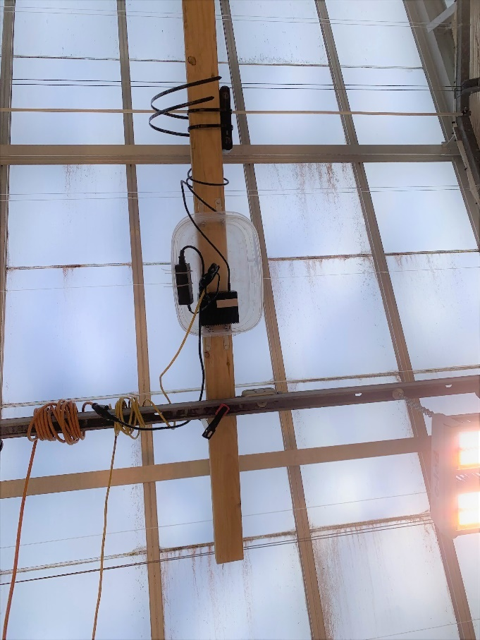

Figure . ZED Camera and ZED Box on Plank Bottom-Up View

To access the ZED box, the ZED SDK was installed into the box interfacing with the connected ZED camera, also a switch was set up to be used as an interface between a laptop and the ZED box. The ZED camera was connected to the ZED box through a USB type A 3.0 cable. The ZED box was connected to the switch and the switch connected to a laptop both through ethernet cables. Figure 9 shows the switch used and the power strip for the ZED Box, ZED Camera, and switch.

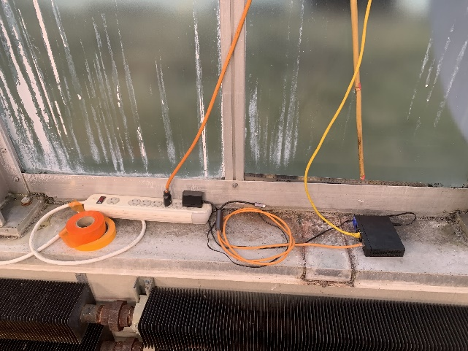

Figure . Switch connected to ZED Box

This initial part of getting the equipment setup involved many issues. One of the biggest issues was networking related. Initial attempts at connecting the ZED box to the school’s network via the switch to be able to access the camera remotely were unsuccessful as the school’s infrastructure didn’t allow it. Other local networking issues arose involving the static vs dynamic IP configuration of the ZED box.

Once access to the ZED box and ZED camera was established the calibration and basic setup of the camera to be able to take appropriate recordings was the next step. Utilizing the ZED API integrated with the ZED SDK on the ZED Box, it was simple to connect to the ZED Camera and capture a recording. Some of the image settings weren’t adequate for the scene and had to be tweaked, including the exposure, gamma, and white balance. There seemed to be a few bugs with the camera that made this process difficult. The ‘auto’ versions of these settings were often ineffective. Figure 10 and 11 show common occurrences when capturing images with the ZED camera where the auto exposure and auto white balance wouldn’t behave adequately.

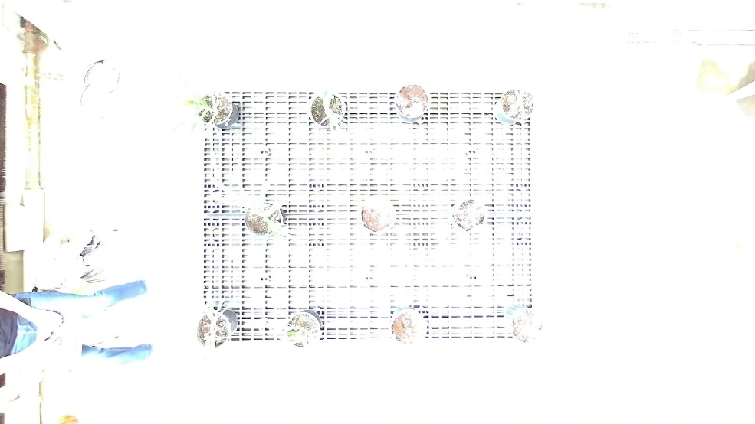

Figure . ZED Image Capture at ‘auto’ exposure

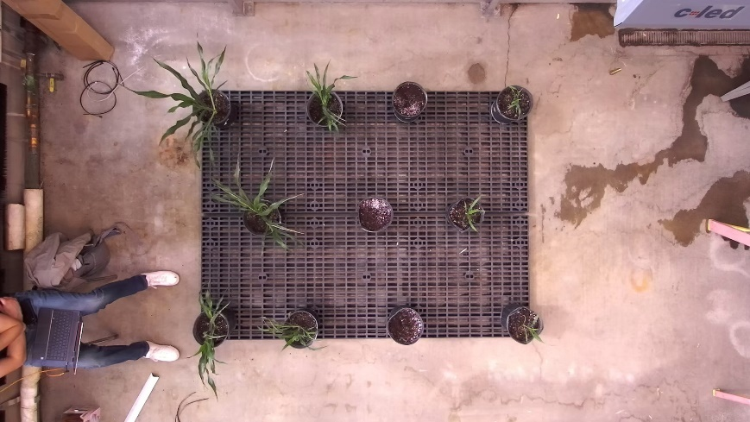

Figure . ZED Image Capture at ‘auto’ white balance

Even when exposure and white balance settings were manually modified, the behavior sometimes didn’t change. The conclusion arrived after experimenting with resolving the issue was that manually entering settings required more ‘camera on’ time to calibrate. When directing the ZED camera to take longer captures, these manual setting modifications were enacted and resulted in appropriate images as shown in Figure 12.

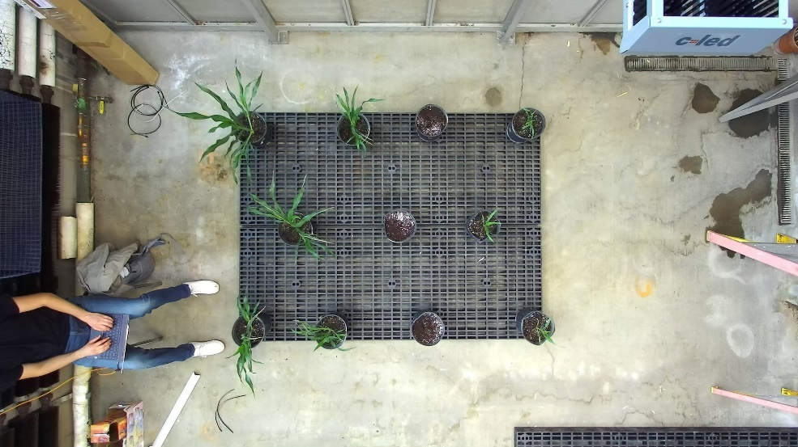

Figure . ZED Image Capture properly calibrated

Once the ZED camera was calibrated to take the appropriate photos, the next step was writing and setting up the scripts that would automatically collect the recordings throughout the next few months. This involved utilizing the ZED SDK to take SVO recordings. These recordings are various frame captures of the camera and can be processed by the ZED SDK to create plain 2D images, point clouds, meshes, and other renderings not needed in this project. The code that directs the camera to capture SVO recordings involves initializing the camera with the appropriate parameters and camera settings and then simply recording the frames.[1]

In order to capture SVO recordings recurringly over the course of a few months, a bash script was written that ran the SVO recording capture script in the background. At first the ‘nohup’ linux command was used to run recordings in the background. However, this command led to some issues and thus the ‘screen’ linux command was used for the background operation. An issue relating to camera overheating arose as well. The only permanent solution found was making the resolution of the recordings 1080 p instead of 2K.

### 3.1.3 Control Photos

Once data collection was setup, control and calibration photos were taken. These were taken to determine the precision and accuracy of the point clouds generated from the camera’s recordings and in case software calibration was needed. An artificial plant and a ruler at different distances from the camera were acquired. Figure 15 shows an image of an artificial plant. Figure 16 shows an image of a ruler directly below the camera. Figure 17 shows an image of a ruler in the far-right side of the image to measure distortion when nearing the edges of the camera’s field of view.

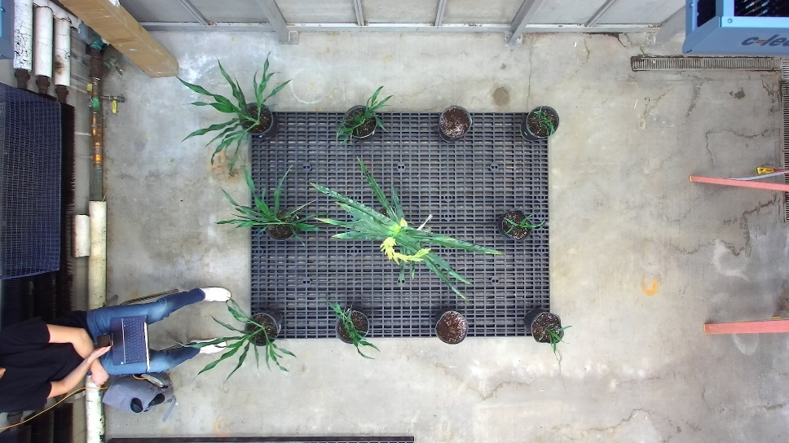

Figure . Calibration Photo of Artificial Plant

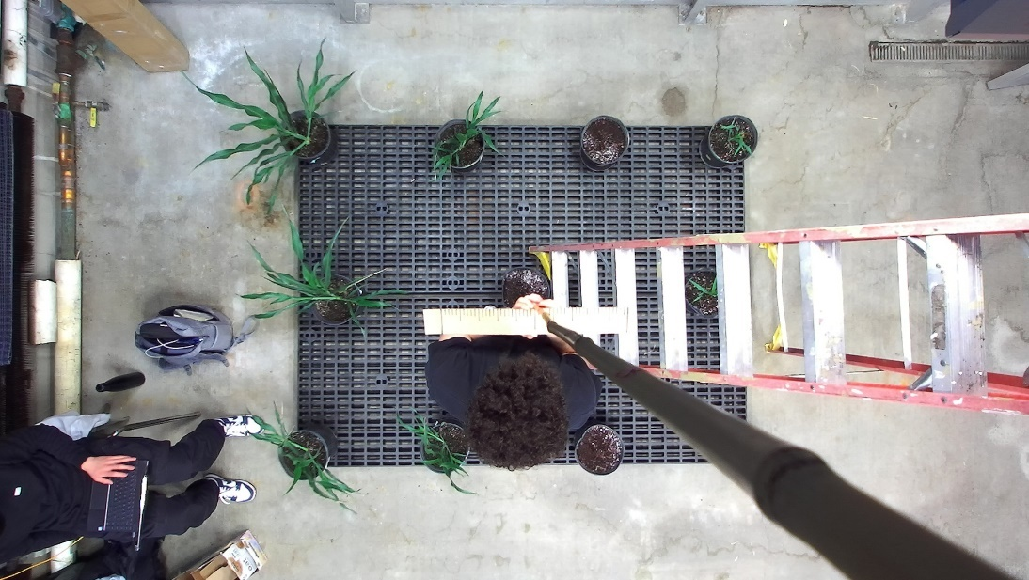

Figure . Calibration Photo of Ruler at 150cm from Camera

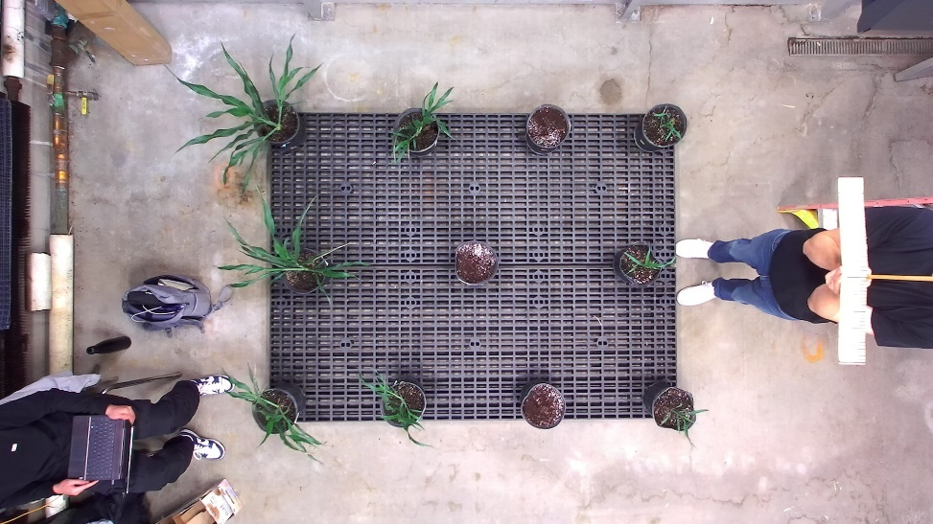

Figure . Calibration Photo of Ruler at 150cm from Camera on Right

## 3.3 Point Cloud and Image Generation

### 3.3.2 Point Cloud and Image Generation

Once the data was collected properly the next step was to convert the raw SVO recordings into the files that would be used for the project: 2D color images and point clouds. The ZED SDK contains the functionality and abstracts it to make it easy to use. Attributes like ‘VIEW.LEFT’ and ‘MEASURE.XYZRGBA’ allow easy extraction of 2D images and point clouds from SVO recordings. An example 2D Image taken from the left camera extracted from an SVO recording is shown in figure 13. An example point cloud produced by the SDK is shown in Figure 14.

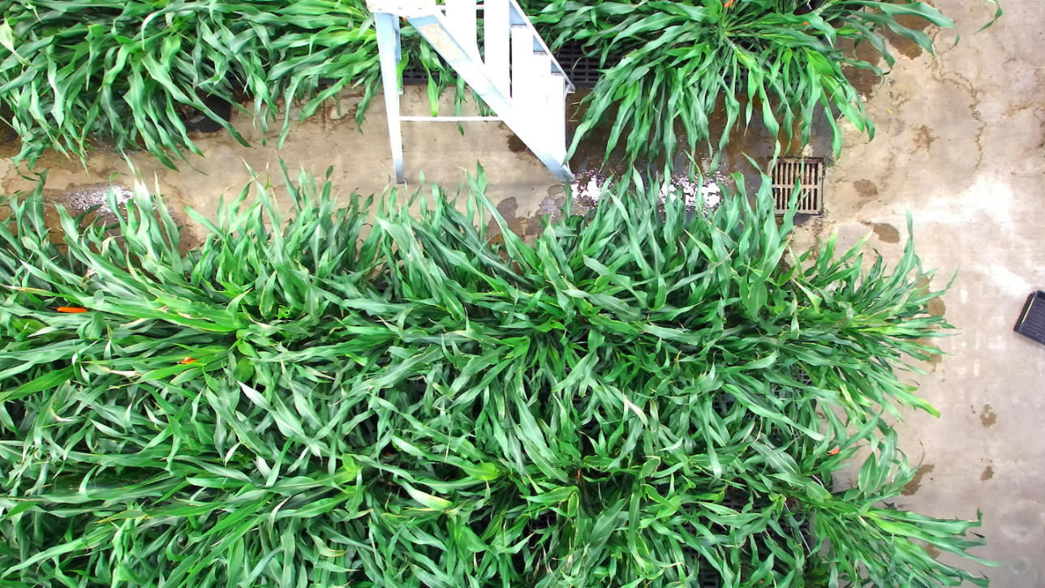

Figure . RGB 2D Left Stereo Image

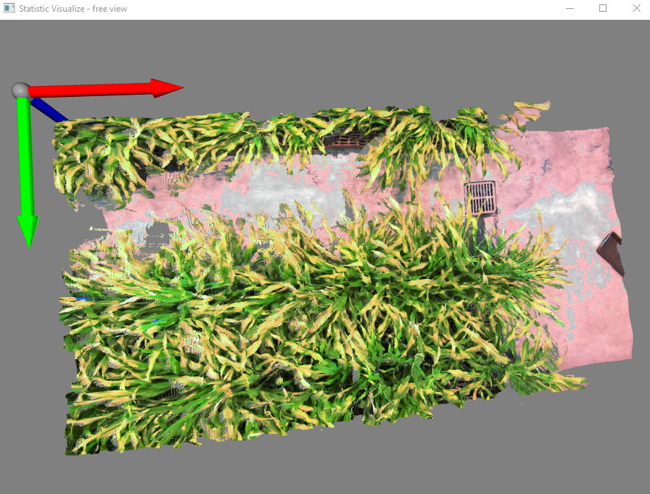

Figure . Resulting Point Cloud

The 2D images are exported in JPG format. The point cloud is exported as an OBJ file utilizing the sample code in the ZED SDK examples. However, to make the data easier to manipulate in later sections of the project, custom code was written to extract the point cloud data into a basic text file that only includes the X, Y, Z coordinates of the points and the R, G, B color values.[2]

The custom point cloud extraction with the use of the ZED SDK was also useful in providing point cloud with greater quantity of points. Figure ____ shows a point cloud generated with the native export point cloud code in the SDK rendered in Mesh Lab on the right, compared to a point cloud generated with the custom point cloud formatting code rendered with Open 3D on the left.

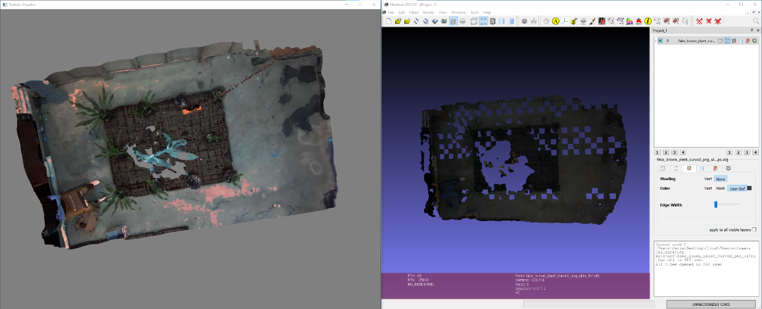

Figure . Point Cloud

This is the case across the different recordings taken with the ZED camera.

## 3.4 Training Mask R-CNN Model

With the raw 2D images and point cloud as input and an instance of an individual leaf as the desired output, an instance segmentation model is required for the next portion of the project. To best utilize the instance segmentation model, high quality and diverse annotated data is used to train, validate, and test the model. So, there’s three ideal components to the data: high quality, annotated, and diversity. The images captured were as high quality as the ZED camera and ZED box allowed. The annotation is required after acquisition of the high-quality images to help train the model detect the objects labeled. The diversity of the data is acquired by capturing images in three different greenhouse rooms and by utilizing different cameras, ZED camera and go pro. It is now relevant to mention that data captured for another project with the go pro camera was utilized in this project for training the instanced segmentation model to add diversity. Diversity of the data can also be added through image augmentation. This process involves transforming raw images through color modifications, rotations, scaling, etcetera and feeding these transformed images into training the model. The sequence described is visualized in figure 18.

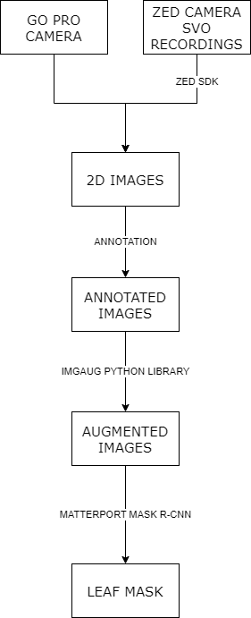

Figure . Training Mask R-CNN Model Workflow

What’s left to complete the workflow visualized in figure 18 is annotation, augmentation, and using the Mask R-CNN model for training and inferencing.

### 3.3.1 Image Annotation

For accomplishing the annotation task and annotating the 2D images obtained from the ZED camera’s SVO recordings, this project used the open source VGG Image Annotator. As no edits to the source code were required for this project and the tool is available for use online, this project utilized the online version of VGG Image Annotator. Annotation was accomplished by importing an image, annotating clear and flatter leaves with the polygon tool, and exporting the annotations in a .JSON file. Figure 19 showcases the tool being used.

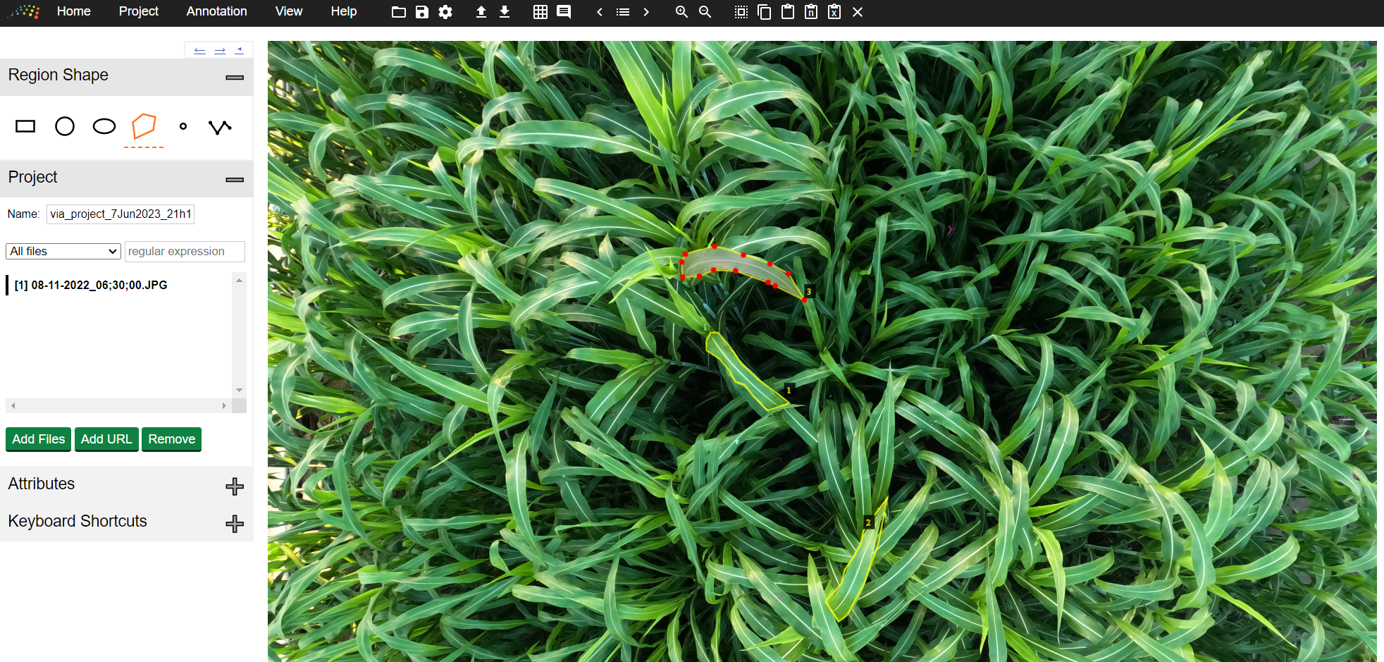

Figure . VGG Image Annotator

### 3.3.2 Image Processing Pre-Training

First the annotation masks are cropped to avoid processing the excess zeros around the mask and minimize computation when training the model. Then these annotation masks are applied to the images.

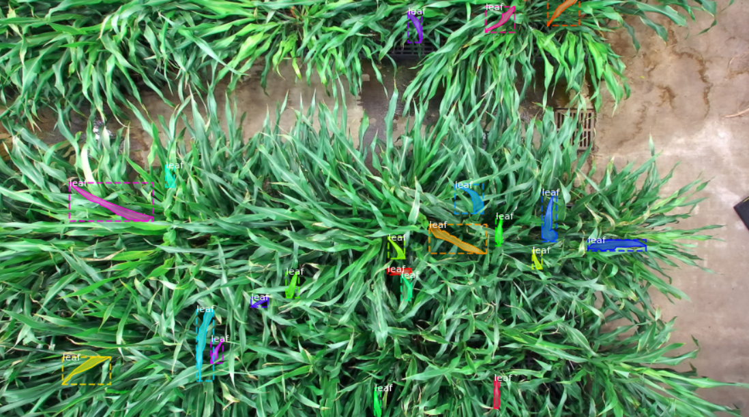

Figure . Annotated Image

Second the image augmentation is applied to the images. The augmentation of the images was accomplished via the python imgaug library. The transformations used on the images include rotation, vertical/horizontal flipping, color changes, blurring, and scaling. Figure 20 showcases one of the images transformed via a few of the image augmentation methods.

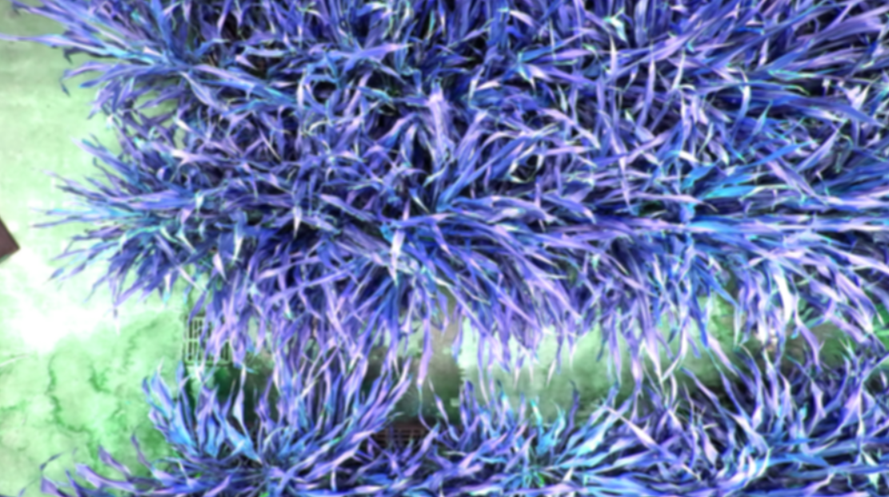

Figure . Augmented Image

### 3.3.3 Model Training

With the processed images ready for training, the following step requires using Mask R-CNN to train a model than can detect and segment individual leaves. An open-source implementation of Mask R-CNN[3] with tensorflow and keras from Matterport was used to implement the instance segmentation model. The model was trained on a remote machine with access to two GPUs for training and image processing purposes. The remote machine operated on two Nvidia GPUs and CUDA version 9.0.

Table 1 outlines the configurations for the matterport implementation of Mask R-CNN. Almost all parameters are the default ones. The only one changed parameter is that of “GPU_COUNT” to specify the number of GPUs this project had access to.

The model was trained on the 2017 COCO dataset as a baseline and the sorghum plant dataset built for this project. The model was trained for 30 epochs each with 100 steps. The standard output of training for the last few epochs is displayed in figure 22.

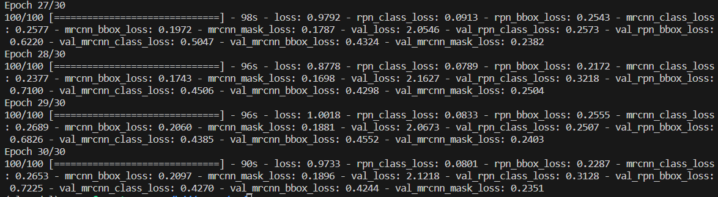

Figure . Training Output

ELABORATE IN THIS SECTION

### 3.3.4 Model Prediction

When using the model to predict the masks of leaves on the test dataset, the same configuration parameters as in table 1 were used.

Using the model to predict the leaf masks in an image involves 3 main stages. Stage 1 is using the Region Proposal Network (RPN), running a binary classifier on anchors that covers the entire image, to output region proposals. Region proposals are bounding boxes covering regions that are most likely the location of a leaf to be segmented. Stage 2 is the Proposal Classification. Stage 2 classifies the region proposals per class, including class probabilities and bounding box regressions. After stage 2 some refinement is done: adjusting bounding boxes, filtering out low confidence detections. After this stage 3 is takes the detections from the previous layer and runs the mask head to generate segmentation.

At the end of the process, after running a test image through the training process, some leaves are precisely masked. This can be viewed in Figure 23.

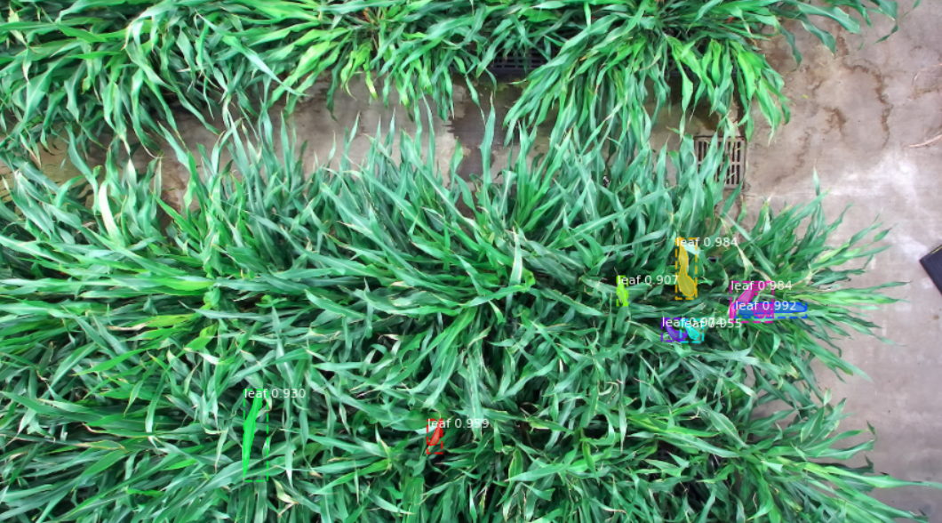

Figure . Test Image with Inferenced Leaf Masks

## 3.4 Leaf Scaling

## 3.5 Point Cloud Cropping

# 4. Research Results

All the five steps outlined in the methodology chapter have their own technique for validation. This chapter will outline the results of each section of the project and demonstrate how each section was validated.

## 4.1 Data Collection and Rendering

In order to validate that the camera produces accurate data and the renderings accurately capture the information in the SVO recordings a set of control photos were taken with the ZED camera to compare real and vision-based measurements. Examples of these control photos are displayed in Figures ______.

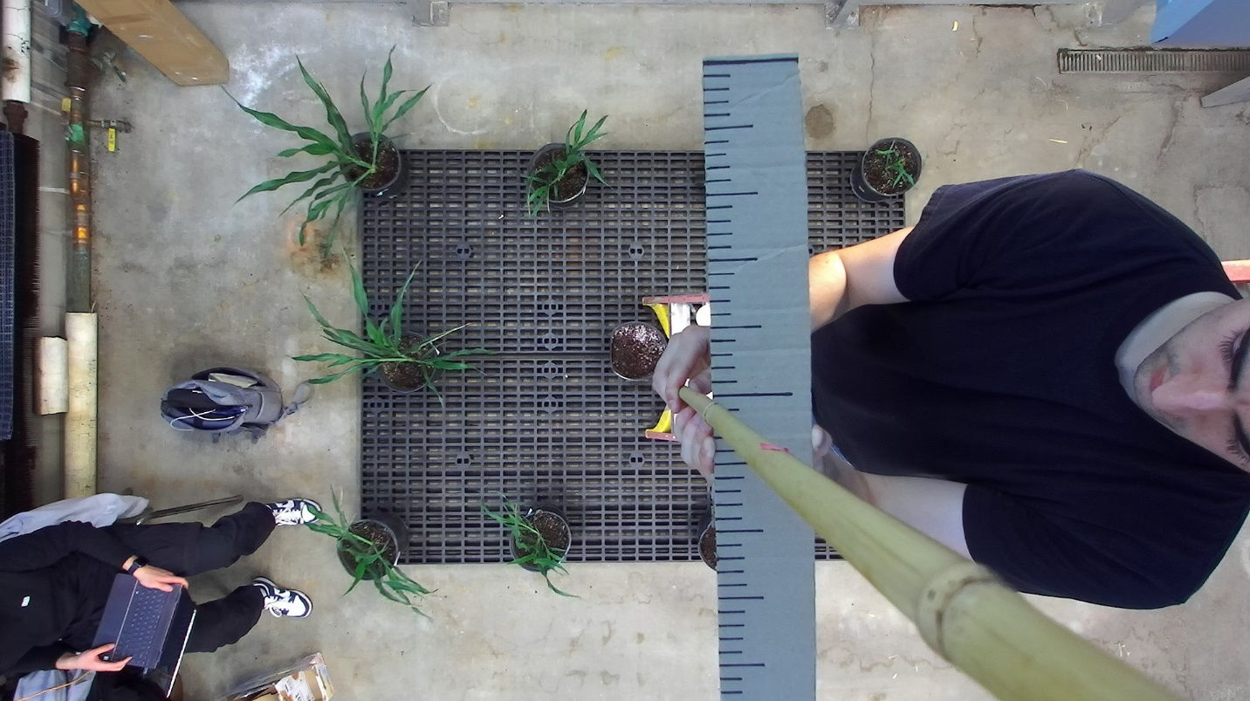

Figure . Control Photo of a Ruler 50 cm From the Camera’s Lens

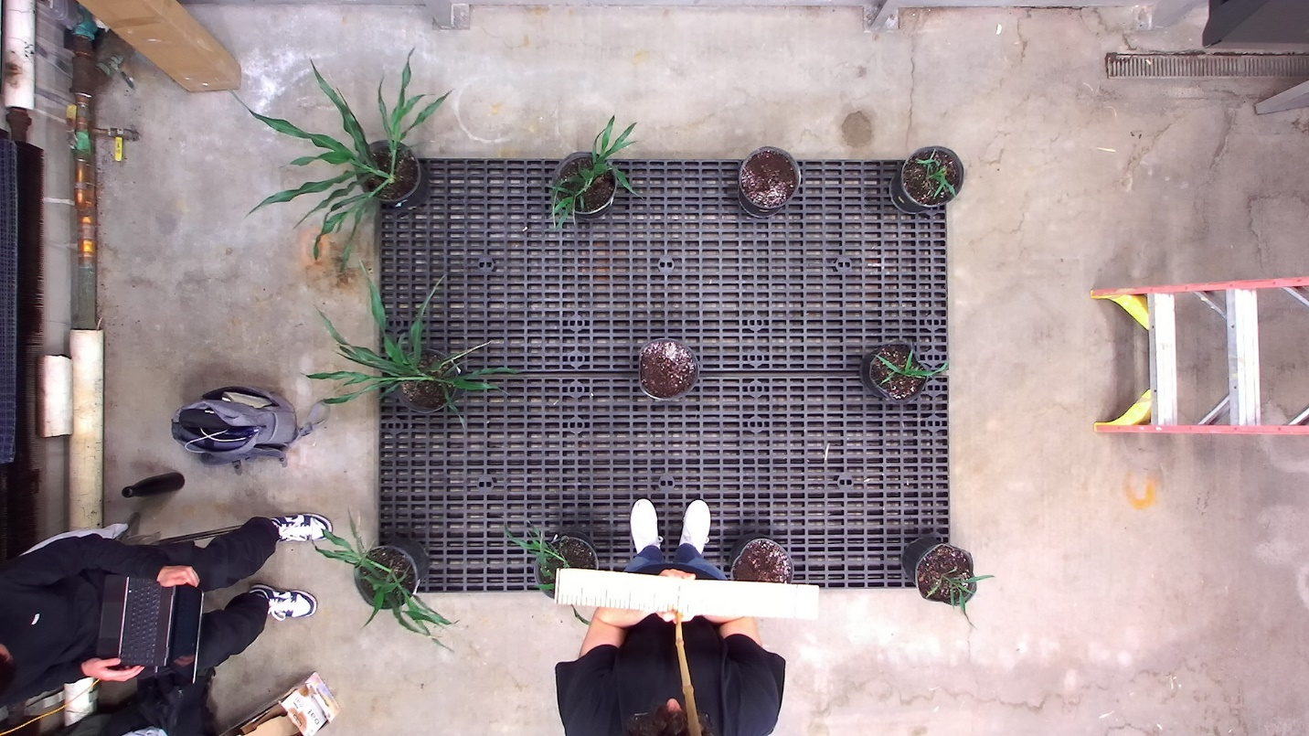

Figure . Control Photo of a Ruler 150 cm From the Plane of The Camera’s Lens ***** FIGURE OUT DISTANCE FROM CAMERA -> real distance, and both legs

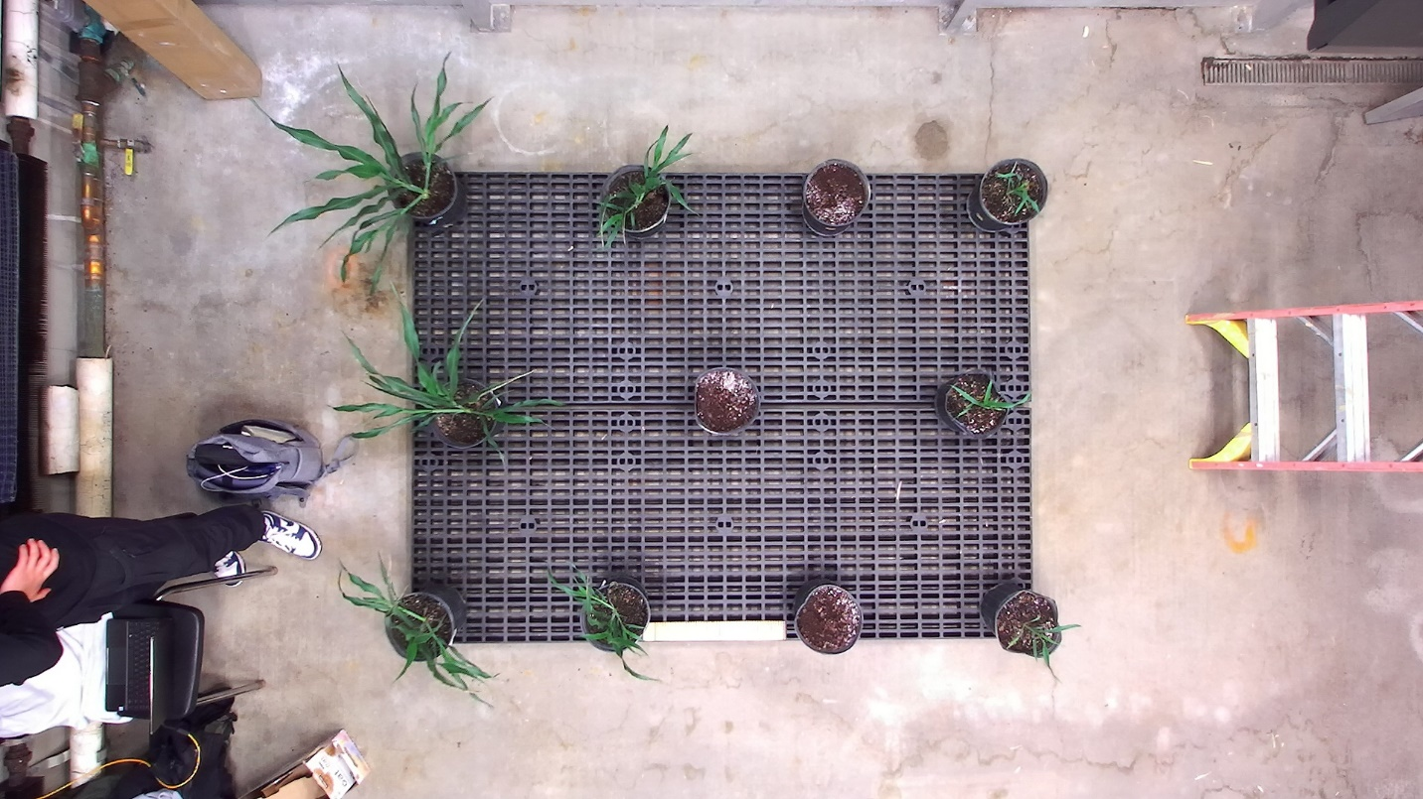

Figure . Control Photo of a Ruler 3__ cm From the Plane of The Camera’s Lens ***** FIGURE OUT DISTANCE FROM CAMERA -> real distance, and both legs

After generating the point cloud of the control recordings and rendering the point cloud using a point cloud visualization tool powered by the open 3d python library, vision-based measurements were taken along the ruler in order to populate metrics that help demonstrate the precision of depth, length, and width vision-based measurements. Two areas of loss of precision were identified: distance from camera and closeness to the edge of the field of view (FOV) of the camera. The hypotheses of the impact of these metrics were that a higher distance from the camera would correlate with lower precision of measurements and higher closer to the edge of the camera FOV would contribute to possible distortion and lower precision of measurements.

Table 1 and 2 showcase data intended to demonstrate trends with regards to precision dependent on the measurement’s distance to the camera. Table 1 showcases depth measurements taken across the different recordings. Table 2 showcases length/width measurements taken across the different recordings. Vision-based measurements taken at 25 cm from the camera are unpopulated as the point clouds generated from the recordings were not able to generate points of objects at 25 cm or closer to the camera. The generated point clouds included objects at 50 cm and further from the camera. These measurements are populated and are used to determine trends in the precision of recordings and rendered point clouds across the different dimensions.

Table . Depth Measurements Taken at Different Distances from Camera

|  |  |  |  |
| --- | --- | --- | --- |
| Real Distance | Point Cloud Distance | |Expected – Actual| | Percent Error |
| 25 cm | - | - | - |
| 50 cm | 50.87 cm | 0.87 cm | 1.74 % |
| 75 cm | 76.02 cm | 1.02 cm | 1.36 % |
| 100 cm | 102.94 cm | 2.94 cm | 2.94 % |
| 125 cm | 127.84 cm | 2.84 cm | 2.27 % |
| 150 cm | 162.42 cm | 12.42 cm | 8.28 % |

Table . Length/Width Measurements Taken at Different Distances from Camera

|  |  |  |  |  |
| --- | --- | --- | --- | --- |
| Distance From Camera | Real Distance | Point Cloud Distance | |Expected – Actual| | Percent Error |
| 25 cm | 1 cm | - | - | - |
| 50 cm | 1 cm | 1.0127 cm | 0.0127 cm | 1.27 % |
| 75 cm | 1 cm | 1.0246 cm | 0.0246 cm | 2.46 % |
| 100 cm | 1 cm | 1.0335 cm | 0.0335 cm | 3.35 % |
| 125 cm | 1 cm | 1.0845 cm | 0.0845 cm | 8.45 % |
| 150 cm | 1 cm | 1.1850 cm | 0.1850 cm | 18.50 % |

The associated graph displaying the trend of the data in Table is shown in figure ___. The associated graph displaying the trend of the data in Table 2 is shown in figure ____.

Figure . Percent Error of Depth Measurement vs Distance from Camera

Figure . Percent Error of Length/Width Measurement vs Distance from Camera

Table 3 showcases data intended to demonstrate trends with regards to precision dependent on the measurement’s closeness to the edge of the FOV of the camera. Table 3 showcases length/width measurements taken across the different recordings. …

Table . Length/Width Measurements Taken at Different Locations in View and Distances from Camera ******* INCLUDE MORE MEASUREMENTS, MENTION HOW SIDE MEASUREMENTS WERE GOOD BECAUSE THOSE WERE CLOSE ENOUGH TO VIEWING EDGE

|  |  |  |  |  |
| --- | --- | --- | --- | --- |
| Location in View | Real Distance | Point Cloud Distance | |Expected – Actual| | Percent Error |
| Centered at 150 cm | 1 cm | 1.0845 cm | 0.0845 cm | 8.45 % |
| Far-Right at 150 cm | 1 cm | 1.1850 cm | 0.1850 cm | 18.50 % |
| Far-Right at 300 cm | 1 cm | 1.3877 cm | 0.3877 cm | 38.77 % |

Figure . Percent Error of Depth Measurement vs Distance From Camera

The chart demonstrating the precision of the vision-based measurements relative to the actual measurements is shown in figure _____.

## 4.2 Instance Segmentation Model and Leaf Mask

In order to validate that the trained model produces predictions that are precise and accurate, the project uses one of the Matterport Mask-RCNN sample’s model validation jupyter notebooks to quantitatively demonstrate the quality of the predictions. ……………………… (talk about and show figures of these demonstrations)

FIGURE _______

In order to validate that an individual leaf mask is being isolated and can be used as a filter, the mask has been converted into a black and white image of which the background is white and the mask is black. As figure ____ demonstrates, the individual mask matches exactly with one of the leaf masks represented in the Matterport Mask-RCNN model validation file.

FIGURE_______

## 4.3 Leaf Mask Scaling

The validation for the leaf mask scaling

## 4.4 Point Cloud Cropping

The validation for the point cloud cropping consists of using a point cloud of a known shape filtered by a known mask of a known shape as inputs, producing an expected result. The point cloud of a known shape will be that of a cube, as shown in figure ________. The mask will be that of a circle, as shown in figure _______.

The result of filter the cube with a circle is shown in figure ________

# 5. Discussion

The goal of this research is to define a method and develop a program that researchers can use to acquire leaf models for plants in environments with dense leaf clusters. The results of the project demonstrate successful aspects and areas needing improvement. Although the precision and accuracy of some measurements doesn’t make the product of this project ready to be shared, the results give empirical evidence that the method utilized is able to go through the process of acquiring leaf models for plants in environments with dense leaf clusters.T

## 5.1 Data Collection and Rendering

### 5.1.1 Key Findings

Figure ____ showcases the findings from the data collection and rendering validation. The results showcase greater inaccuracy as the object moves further from the camera and closer to the edges of the camera’s view. That said, the accuracy of measurements even 3 meters away and close to an edge of __, is stil ___%. With this information, it is conclusive that the precision of vision-based measurements with the ZED camera is high and performing vision-based measurements with the ZED camera recordings is reliable.

### 5.1.2 Limitations

Although the precision of most relevant points are high. There are several limitations observed from the visualization of the produced point clouds.

* Too few points using native exporting tools from zed sdk
* Loss of precision when depth changes quickly, more loss the greater the depth change
* Loss of points closer than 50 cm away from camera
* Ruler is reflective

### 5.1.3 Future Work

Greater experimentation with the attributes in the zed sdk to see if it does better with depth changes

## 5.2 Instance Segmentation Model and Leaf Mask

### 5.2.1 Key Findings

TO DO

### 5.2.2 Limitations

TO DO

### 5.2.3 Future Work

TO DO

## 5.3 Leaf Mask Scaling

### 5.3.1 Key Findings

TO DO

### 5.3.2 Limitations

TO DO

### 5.3.3 Future Work

TO DO

## 5.4 Point Cloud Cropping

### 5.4.1 Key Findings

TO DO

### 5.4.2 Limitations

“There is a potential issue here that you should mention. If there is occlusion the points in the crop by cause issue with the distance measurement calculations, but I assume these crops would be able to be thrown out using the Reject Leaf algorithm.”

### 5.4.3 Future Work

TO DO

With the point cloud of the leaf, distances are calculated between edge points and the midline of the leaf to determine which edge points define the widest part of the leaf. These edge points are utilized to find the widest width.

# 6. Conclusion

## 6.1 Research Answers

The research aim for this research project is to enable researchers who are conducting experiments on plants that require the collection of phenotyping data to perform the acquisition of data more quickly and precisely. Specifically, by defining a method and developing a program that researchers can use to acquire leaf width for plants in environments with dense leaf clusters.

The research addressed the question posed in the introduction relating to the design of the project.[4]

…………… The instance segmentation algorithm that is most effective for leaf segmentation in environments with dense leaf clusters is the Mask R-CNN model….. The best way to train a model to segment measurable leaves out of a dense cluster with overlapping and curling leaves is by …….. The best methodology for obtaining leaf width while overcoming the problems leaf curling causes is through the calculation of geodesic distances between points in a point cloud ……………… The most effective process at accomplishing the task of measuring leaf width talking raw stereo images as input and the appropriate width measurements as the output is outlined in figure 26.

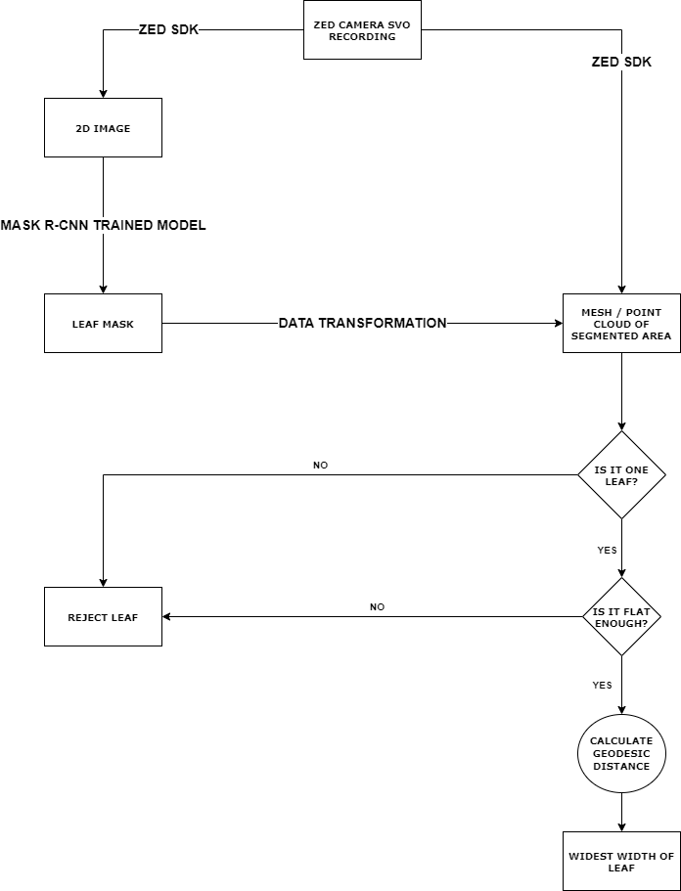

Figure . Next Steps Workflow

## 6.2 Contribution

This project provides plant researchers with a tool to track leaf width in their studies. One of these studies is that of genetically modifying Sorghum to be more resistant to the changes caused by climate change. This tool facilitates plant researchers in conducting their studies quicker, more accurately, and on a larger scale. The greater success of these studies will help prepare humanity for the worsening climate including assisting the potential food scarcity issue especially as the growth of the world population increases.

Although this project was specifically designed for obtaining leaf width for plant genetic researchers, the process and program can be altered and applied to other applications requiring measurements of objects. This could include other types of research: automating food harvesting, facilitating detection of large tumors, etc. This project serves as a baseline for future development and process improvement in the space of object measurement with stereo images. And though the project has some flaws it serves as a first step in the construction of widely applicable object measurement capabilities.

## 6.3 Further Research Opportunities

In planning the

Some studies focus on the Multi-view CNNs (Boulch et al., 2018; Guerry et al., 2017; Kalogerakis et al., 2017), hoping to indirectly realize the understanding of 3D data by strengthening the connection between 2D and 3D via 2D CNNs (Jin et al., 2018a). The main difficulties of this method include that it is hard to determine the angle and the quantity of projection from a point cloud to a 2D image, and how to re-project the segmented models from 2D to 3D space. [PlantNet a dual fun]

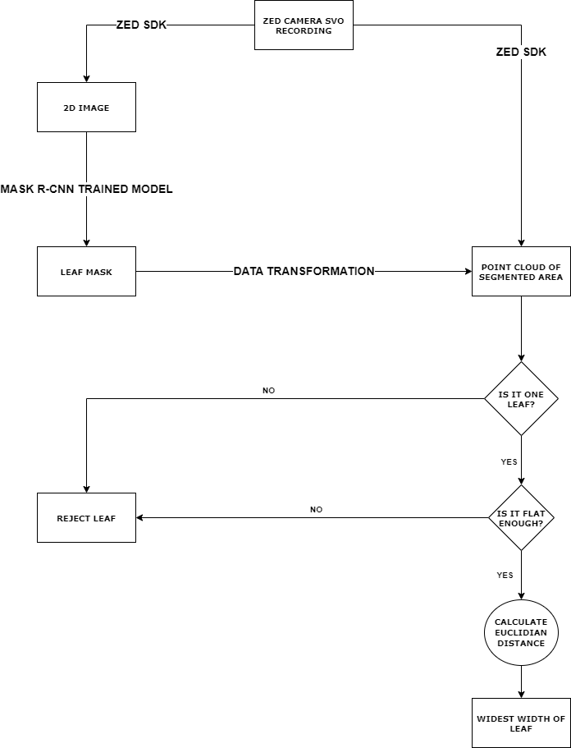

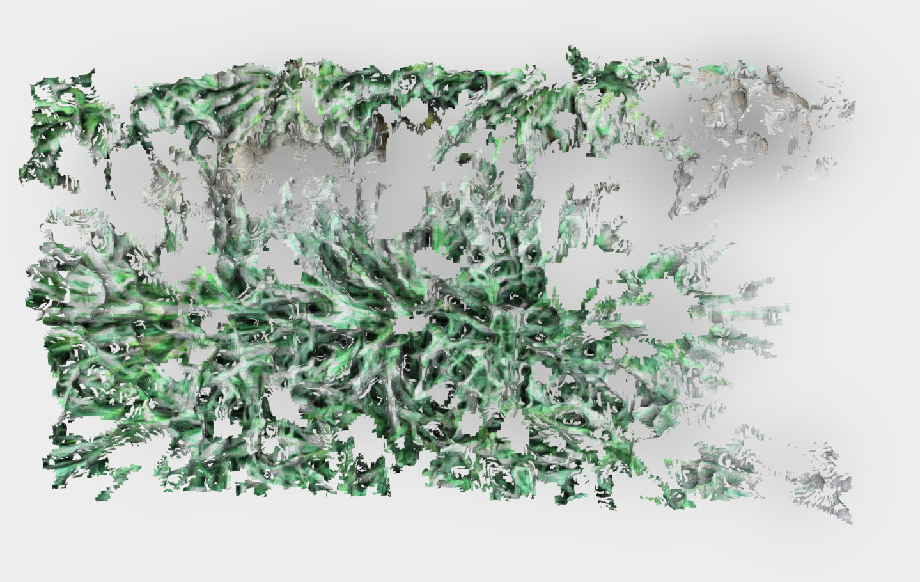

Figure . Mesh

# Appendix A: ZED Camera Image Capture and Processing

## A.1 Overview

TO DO

## A.2 Code

TO DO

1. cam = sl.Camera()

2.

3. init = sl.InitParameters()

4. init.camera_resolution = sl.RESOLUTION.HD2K

5. init.depth_mode = sl.DEPTH_MODE.ULTRA

6. init.SDK_verbose = 1

7. init.SDK_verbose_log_file = "/home/user/Documents/SVO_recording/SDK_log_file/log_file"

8. # other initial parameters have been left blank because default value is adequate

9.

10. recording_param = sl.RecordingParameters(path_output, sl.SVO_COMPRESSION_MODE.H265)

11.

12. runtime = sl.RuntimeParameters()

13. cam.set_camera_settings(sl.VIDEO_SETTINGS.BRIGHTNESS, -1)

14. cam.set_camera_settings(sl.VIDEO_SETTINGS.CONTRAST, -1)

15. cam.set_camera_settings(sl.VIDEO_SETTINGS.HUE, -1)

16. cam.set_camera_settings(sl.VIDEO_SETTINGS.SATURATION, -1)

17. cam.set_camera_settings(sl.VIDEO_SETTINGS.SHARPNESS, -1)

18. cam.set_camera_settings(sl.VIDEO_SETTINGS.GAMMA, -1)

19. cam.set_camera_settings(sl.VIDEO_SETTINGS.GAIN, 0)

20. cam.set_camera_settings(sl.VIDEO_SETTINGS.EXPOSURE, 5)

21. cam.set_camera_settings(sl.VIDEO_SETTINGS.WHITEBALANCE_TEMPERATURE, -1)

22. # other video settings have been left blank because default value is adequate

23.

24. frames_recorded = 0

25.

26. while frames_recorded < 100:

27.     if cam.grab(runtime) == sl.ERROR_CODE.SUCCESS :

28.         frames_recorded += 1

Figure . Capturing an .SVO recording with the ZED Camera

1. input_type = sl.InputType()

2. input_type.set_from_SVO_file(SVO_input_path)

3.

4. init = sl.InitParameters(input_t=input_type, SVO_real_time_mode=False)

5.

6. cam = sl.Camera()

7.

8. runtime = sl.RuntimeParameters()

9. mat = sl.Mat()

10.

11. cam.retrieve_image(mat, sl.VIEW.LEFT)

12. fd = cv2.imwrite(output_path_image, mat.get_data())

13.

14. cam.retrieve_measure(mat, sl.MEASURE.XYZ)

15.

16. pc_list = []

17.

18. for i in range(0, mat.get_width()):

19.     for j in range(0, mat.get_height()):

20.         err, val = mat.get_value(i,j)

21.

22.         if not np.isnan(val[0]) and not np.isinf(val[0]):

23.             pc_list.append(val[0:3])

Figure . ZED SDK Code for processing SVO recording into 2D image and point cloud

1. augmentation = iaa.SomeOf((4), [

2.     iaa.Fliplr(0.5),

3.     iaa.Flipud(0.5),

4.     iaa.OneOf([iaa.Affine(rotate=90),

5.                 iaa.Affine(rotate=180),

6.                 iaa.Affine(rotate=270)]),

7.     iaa.Multiply((0.8, 1.5)),

8.     iaa.GaussianBlur(sigma=(0.0, 5.0)),

9.     iaa.WithColorspace(

10.         to_colorspace="HSV",

11.         from_colorspace="RGB",

12.         children=iaa.WithChannels(0, iaa.Add((0, 50))))

13.])

Figure . Image Augmentation Configuration

# Appendix B: Instance Segmentation Model

## B.1 Overview

TO DO

## B.2 Code

TO DO

Table . Configurations for Matterport's Mask R-CNN Model

|  |  |
| --- | --- |
| BACKBONE | resnet101 |
| BACKBONE_STRIDES | [4, 8, 16, 32, 64] |
| BATCH_SIZE | 1 |
| BBOX_STD_DEV | [0.1 0.1 0.2 0.2] |
| COMPUTE_BACKBONE_SHAPE | None |
| DETECTION_MAX_INSTANCES | 100 |
| DETECTION_MIN_CONFIDENCE | 0.9 |
| DETECTION_NMS_THRESHOLD | 0.3 |
| FPN_CLASSIF_FC_LAYERS_SIZE | 1024 |
| GPU_COUNT | 2 |
| GRADIENT_CLIP_NORM | 5 |
| IMAGES_PER_GPU | 1 |
| IMAGE_CHANNEL_COUNT | 3 |
| IMAGE_MAX_DIM | 1024 |
| IMAGE_META_SIZE | 14 |
| IMAGE_MIN_DIM | 800 |
| IMAGE_MIN_SCALE | 0 |
| IMAGE_RESIZE_MODE | square |
| IMAGE_SHAPE | [1024 1024    3] |
| LEARNING_MOMENTUM | 0.9 |
| LEARNING_RATE | 0.001 |
| LOSS_WEIGHTS | {'rpn_class_loss': 1.0, 'rpn_bbox_loss': 1.0, 'mrcnn_class_loss': 1.0, 'mrcnn_bbox_loss': 1.0, 'mrcnn_mask_loss': 1.0} |
| MASK_POOL_SIZE | 14 |
| MASK_SHAPE | [28, 28] |
| MAX_GT_INSTANCES | 100 |
| MEAN_PIXEL | [123.7 116.8 103.9] |
| MINI_MASK_SHAPE | (56, 56) |
| NAME | leaves_zed |
| NUM_CLASSES | 2 |
| POOL_SIZE | 7 |
| POST_NMS_ROIS_INFERENCE | 1000 |
| POST_NMS_ROIS_TRAINING | 2000 |
| PRE_NMS_LIMIT | 6000 |
| ROI_POSITIVE_RATIO | 0.33 |
| RPN_ANCHOR_RATIOS | [0.5, 1, 2] |
| RPN_ANCHOR_SCALES | (32, 64, 128, 256, 512) |
| RPN_ANCHOR_STRIDE | 1 |
| RPN_BBOX_STD_DEV | [0.1 0.1 0.2 0.2] |
| RPN_NMS_THRESHOLD | 0.7 |
| RPN_TRAIN_ANCHORS_PER_IMAGE | 256 |
| STEPS_PER_EPOCH | 100 |
| TOP_DOWN_PYRAMID_SIZE | 256 |
| TRAIN_BN | FALSE |
| TRAIN_ROIS_PER_IMAGE | 200 |
| USE_MINI_MASK | TRUE |
| USE_RPN_ROIS | TRUE |
| VALIDATION_STEPS | 50 |
| WEIGHT_DECAY | 0.0001 |

# Appendix C: Leaf Width Measurement Code

## C.1 Cropping with Mask

TO DO

## C.2 Distance Measurement

TO DO

# References

[1] J. Weyler, F. Magistri, P. Seitz, J. Behley, and C. Stachniss, “In-Field Phenotyping Based on Crop Leaf and Plant Instance Segmentation,” *Proc. - 2022 IEEE/CVF Winter Conf. Appl. Comput. Vision, WACV 2022*, pp. 2968–2977, 2022, doi: 10.1109/WACV51458.2022.00302.

[2] G. C. Nelson *et al.*, “Climate change effects on agriculture: Economic responses to biophysical shocks,” *Proc. Natl. Acad. Sci. U. S. A.*, vol. 111, no. 9, pp. 3274–3279, Mar. 2014, doi: 10.1073/PNAS.1222465110/SUPPL_FILE/SD03.TXT.

[3] Y. Li *et al.*, “Automatic organ-level point cloud segmentation of maize shoots by integrating high-throughput data acquisition and deep learning,” *Comput. Electron. Agric.*, vol. 193, p. 106702, Feb. 2022, doi: 10.1016/J.COMPAG.2022.106702.

[4] J. Schrader, G. Pillar, and H. Kreft, “Leaf-IT: An Android application for measuring leaf area,” *Ecol. Evol.*, vol. 7, no. 22, pp. 9731–9738, Nov. 2017, doi: 10.1002/ECE3.3485.

[5] D. Li *et al.*, “PlantNet: A dual-function point cloud segmentation network for multiple plant species,” *ISPRS J. Photogramm. Remote Sens.*, vol. 184, pp. 243–263, Feb. 2022, doi: 10.1016/J.ISPRSJPRS.2022.01.007.

[6] K. Turgut, H. Dutagaci, G. Galopin, and D. Rousseau, “Segmentation of structural parts of rosebush plants with 3D point-based deep learning methods,” *Plant Methods*, vol. 18, no. 1, pp. 1–23, Dec. 2022, doi: 10.1186/S13007-022-00857-3/TABLES/11.

[7] L. Xu, Y. Li, Y. Sun, L. Song, and S. Jin, “Leaf instance segmentation and counting based on deep object detection and segmentation networks,” *Proc. - 2018 Jt. 10th Int. Conf. Soft Comput. Intell. Syst. 19th Int. Symp. Adv. Intell. Syst. SCIS-ISIS 2018*, pp. 180–185, Jul. 2018, doi: 10.1109/SCIS-ISIS.2018.00038.

[8] J. Champ, A. Mora-Fallas, H. Goëau, E. Mata-Montero, P. Bonnet, and A. Joly, “Instance segmentation for the fine detection of crop and weed plants by precision agricultural robots,” *Appl. Plant Sci.*, vol. 8, no. 7, p. e11373, Jul. 2020, doi: 10.1002/APS3.11373.

[9] C. R. Qi, H. Su, K. Mo, and L. J. Guibas, “PointNet: Deep Learning on Point Sets for 3D Classification and Segmentation.” pp. 652–660, 2017.

[10] R. Girshick, “Fast R-CNN.” pp. 1440–1448, 2015. Accessed: Jun. 05, 2023. [Online]. Available: https://github.com/rbgirshick/

[11] S. Ren, K. He, R. Girshick, and J. Sun, “Faster R-CNN: Towards Real-Time Object Detection with Region Proposal Networks,” *Adv. Neural Inf. Process. Syst.*, vol. 28, 2015, Accessed: Jun. 05, 2023. [Online]. Available: https://github.com/

[12] K. He, G. Gkioxari, P. Dollár, and R. Girshick, “Mask R-CNN,” *IEEE Trans. Pattern Anal. Mach. Intell.*, vol. 42, no. 2, pp. 386–397, Mar. 2017, doi: 10.1109/TPAMI.2018.2844175.

1. For more information read Appendix A
2. For more information read Appendix A
3. For more information on how the model is trained read “Mask R-CNN” [12]
4. For more information read section ‘1.2’ of this paper